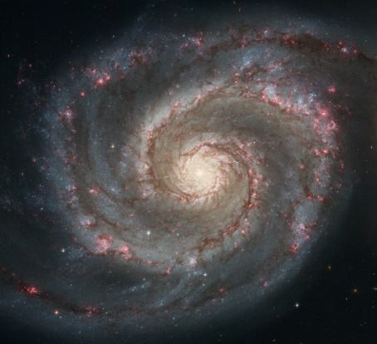  A  Answer the questions below about the Milky Way Galaxy  C  - What type of galaxy is the one displayed in this picture?  B  - What type of stars are located at the arms of the galaxy?  - Which letter shows the location of our sun?  - Which letter shows the location of the bulge of the galaxy?  - Describe (using complete sentences) the location of our sun in the galaxy. | 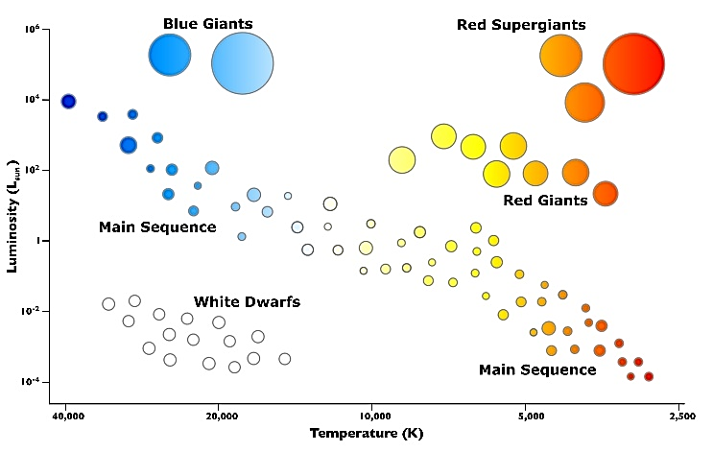  Answer the questions below about the HR diagram  X  - Explain the temperature and luminosity of white dwarf stars?  - Which type of stars are very cold and very bright?  - Which type of stars are very bright and very hot?  - Which star is located at X?  - What type of stars are hot and dim?
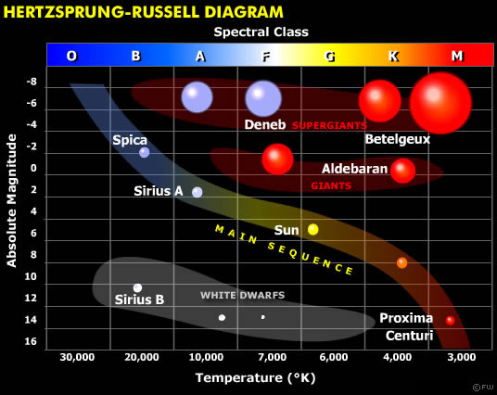  - Which star shows to have an average heat and average temperature?  - What type of star is our sun?  - Which type of stars form a diagonal line across the HR diagram?  - Describe the temperature and brightness of our sun. | A  B  C  All cars are driving at 120 mph during the race  - Define speed  - Define velocity  - Define acceleration  - Which car shows a change in velocity?.. A, B, or C? Explain.
Consider the picture below to answer the following questions. The car has a speed of 2.5 m/s first, 5.8 m/s later and 12.8 m/s at the end  A  B  C  - What is happening to the speed of the car as it travels down the ramp?  - What is the velocity of the car at point C? Explain  - Does the car has acceleration? Explain  - What are the forces pushing the car?  - What are the forces stopping the car?  - Are the forces balanced? Explain | 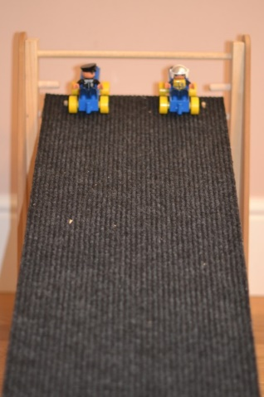  The ramp on this picture has a carpet as a surface. Consider that information to answer the following questions  - Is this surface efficient for racing the cars down the ramp?  - What changes can you do to the ramp to increase the acceleration of the car without increasing the height?  Carpet surface
Material Time (seconds)  carpet 3.5  sand 5.8  wood 2.8  concrete 2.5  The data table shows the time that the car took to complete the ramp using different materials on its surface.  - Over which surface material can the car travel faster?  - Over which material does the car goes slower?  - Which two surfaces are the best to run the car? | - Which ramp will produce less speed? Why?  - Which ramp will produce more speed? Why?  - What forces are pushing the car?  - What forces are slowing the car down?  - Are the forces balanced or unbalanced?  - Which force wins, and has a net-force at the end?

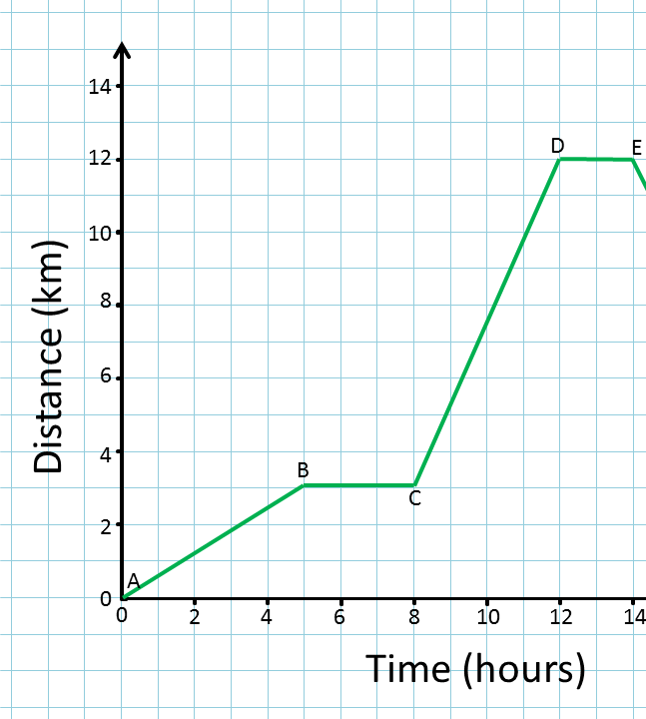  Use the following graph to answer the questions below  - What are the 3 types of motion?  - What type of motion can you measure with this graph?  - What are the two components of speed?  - Which two sections represent constant speed?  - What is happening at points B-C and D-E?  - Which points show the fastest motion?  - What is the speed at point D? Show all your work: formula, substitution, and answer. | 3 kg  Answer the questions below and show all your work. Use the 3 steps method (formula, substitution, answer)  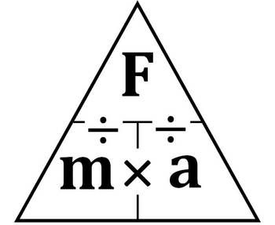  - If the boy kicks the ball with 120N of force, what will be the acceleration?  - If the ball accelerated at 80 m/s², what was the force used when the ball was kicked?  - If the ball is inflated more, and is kicked with 150N of force, and accelerates at 30 m/s², what will be the weight of the ball now after adding air?
- Label the following information about the images provided  A  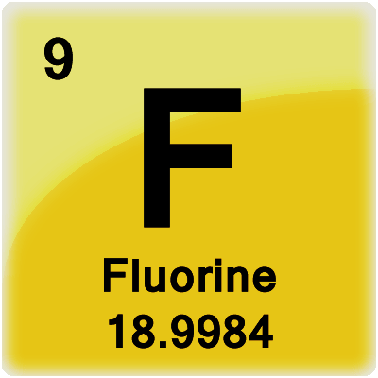  D  C  B  - Label the following information of the atom:  Proton, electron, neutron  - Which element is it?  - What is the atomic number?  - What is the mass? | 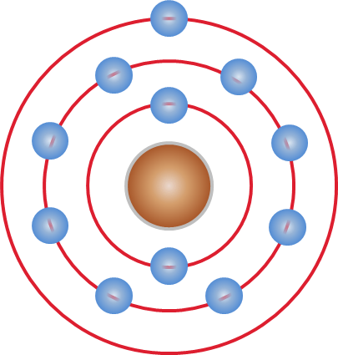  Show your APE MAN strategies to answer the questions below  - What is the atomic number?  - How many protons?  - How many electrons?  - How many neutrons?  - How many valence electrons?  - Which elements is it?
Answer the questions about these chemical formulas?  CH₃OH = alcohol  H₂SO₄ = Sulfuric acid  - How many elements are in sulfuric acid?  - How many Oxygen atoms in alcohol?  - How many Sulfur atoms?  - How many atoms in the entire molecule for sulfuric acid?  - How many elements in alcohol?  - How many hydrogens in alcohol?  - How many atoms in the entire alcohol molecule? | Determine if the following chemical equations are balanced. Do your strategies! Separate the elements on both sides of the yield, and write the number of atoms for each element. Circle the equations that are balanced  - 4P + 5O₂ → P₄O₁₀  - H₂O₂ → H₂O + O₂  - Fe + H₂O → Fe₃O₄ + H₂  - 2Al₂ O₃ → 4Al + 3O₂  - N₂ + 3H₂ → 2NH₃
- Write the name of three elements that are noble gases  - What do these elements have in common: C, O, and Ne?  - Which element is in group 13 and period 3?  - Which element has 7 valence electrons and is period 2?  - Which element has 3 valence electrons and is smaller than Ne? | 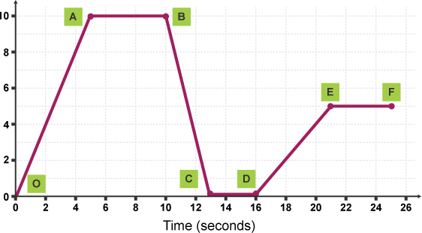  Position (m)  Use the speed formula and your 3-step strategies to answer the questions below. Show all your work.  - What is the speed at point A?  - What is the speed at point A-B?
- Identify the following elements with the information given  Protons = 4 Neutrons= 5 Electrons= 4 Element _________________  Protons = 11 Neutrons= 12 Electrons= 11 Element _________________  Protons = 9 Neutrons= 10 Electrons= 9 Element _________________  Protons = 3 Neutrons= 4 Electrons= 3 Element _________________ | Use the speed formula and the 3-step strategies to answer the following question.  300 km  150 km  - A biker travels from Harlingen to Victoria TX. At 11 AM, the bike passes the 150-km marker. At 4 PM, the biker passes the 300-km marker. What is the average speed of the biker?
- Name the elements of the following atomic structures.  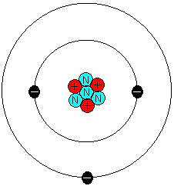  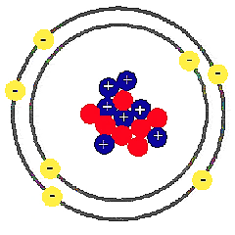 | 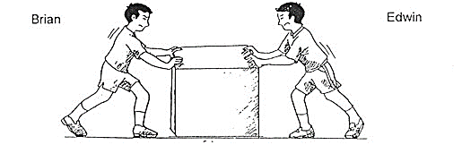  Brian wants to push the box to the right into the garage.  - Is Edwin helping Brian move the box?  - What will be the net force if the boys are applying the same amount of force?  - Edwin pushes with 90N and Brian with 50N. Is this balanced or unbalanced?  - In which direction will the box move?  - What will be the net force?  - If Edwin wants to help Brian put the box in the garage, what does he needs to do?
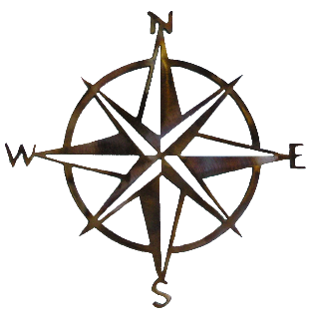  - In which direction is the boy trying to go?  - In which direction will the boat go after he steps?  - Which law of motion does this picture represent?  - If the boy steps with a speed of 5 km/ hr. west, is this an example of speed, velocity, or acceleration? | - How many neutrons are in the following elements?  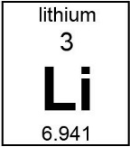  Amount of neutrons? _________  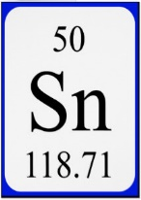  Amount of neutrons? _________  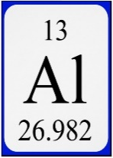  Amount of neutrons? _________  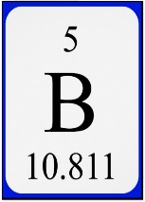  Amount of neutrons? _________
- How can you find the mass of the following atoms?  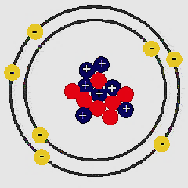  Mass number? _______  Mass number? _______  Mass number? _______  Mass number? _______ | - Use the triangle formula and your 3-step strategies to find the force of the impact against the wall for each person. Show all your work.  A.  The nerd weights 65 kg and runs at 20 km/h  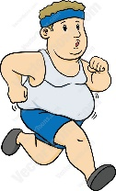  B.  The fat boy weights 140 kg and runs at 10 km/h  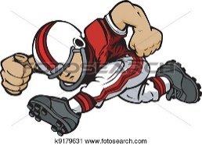  C.  The football player weights 90 kg and runs at 25 km/h

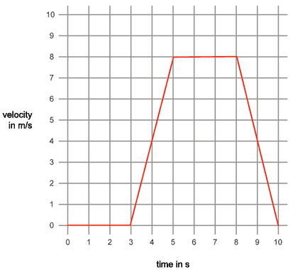  Segment C  Segment B  Segment D  Segment A  - What type of graph is this?  - Which segment shows increasing acceleration?  - Which segment shows decreasing acceleration?  - Which segment shows constant, or no acceleration? | A  B  C  D  E  A child will be riding this slide. He sits ready to go first, he slides with increasing speed, and he stops at the end.  - At which point is the child waiting to go?  - Are there balanced or unbalanced forces on question 96?  - At which points is the child increasing speed?  - Are there balanced or unbalanced forces on question 98?  - At which point did the child stopped?  - Are there balanced or unbalanced forces in question 100?
- The Law of Conservation of ____________ states that matter cannot be created nor __________________, it can only be converted from one form to ________________.  That means that, in a chemical equation, the number of atoms on the reactants, must be _________________ to the number of atoms on the _____________________.  Label the following from the chemical equations:  N₂ + 3H₂ → 2NH₃  - Write the reactants  - Write the products  - How many atoms do I have in the following reactants  2 Al₂ O₃ → 4Al + 3O₂  - How many total atoms should I have on the products if the equation is balanced? | 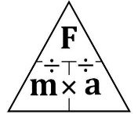  Complete the following Force, Mass, and Acceleration problems. Use your 3-step strategies and the formula triangle. Use proper units.  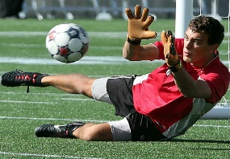  - A player kicks the ball with 25.4 N of force. If the ball weights 0.60 kg, what will be the acceleration of the ball?  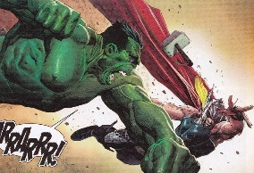  - The Hulk weights 800 kg. He accelerates his punch with 200 m/s² when hitting Thor. What was the force that he applied?  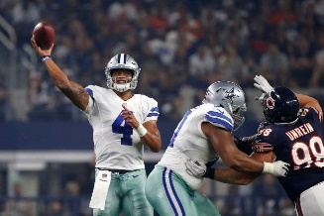  - What is the mass of the football if the quarter-back throws it with a force of 90 N, and it accelerates at 15 m/s²?
In the equation below, methane combines with 2 molecules of oxygen to form carbon dioxide and 2 molecules of water.  - List the compounds in the reactants.  - List the compounds on the products.  - How many atoms will 8 molecules of water have?  - How many atoms are in 6 molecules of carbon dioxide?  - How many atoms are in 8 molecules of methane?  - How many atoms are in 10 molecules of oxygen | 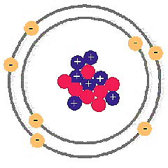  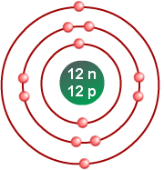  - Which of the 4 atoms belong on the same group?  - Explain how you reached your answer?
The combination of nitrogen and 3 molecules of hydrogen to form ammonia is shown below.  N₂ + 3H₂ → 2NH₃  - Is this an example of physical change?  - Is this an example of chemical changes?  - What type of molecules are in the reactants?  - What are the molecules in the products? | Finally, you are free to go… Make sure you make a 100 on the semester exam and make mami proud.

