Energy Transformation
What is Energy? | What is the “Law of Conservation of energy?”

Describe the type of energy below
Potential Energy (stored energy) | Kinetic energy  (in motion)

Chemical | Nuclear | Elastic | Gravitational | Mechanical | Electrical | Thermal | Radiant | Sound

Name __________________________________ Date ________________ Period _________

Energy Transformation Worksheet

Instructions: Write the energy conversion that takes place at the pictures below.

- Windmill

Energy Transformation:
- Turning a flashlight on

Energy Transformation:
- Heating food on a microwave oven

Energy Transformation:
- Lightning a match

Energy Transformation:
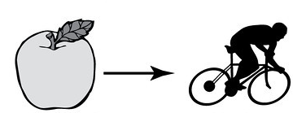 | - Eating and exercising  Energy Transformation:
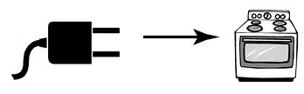 | - cooking  Energy Transformation:
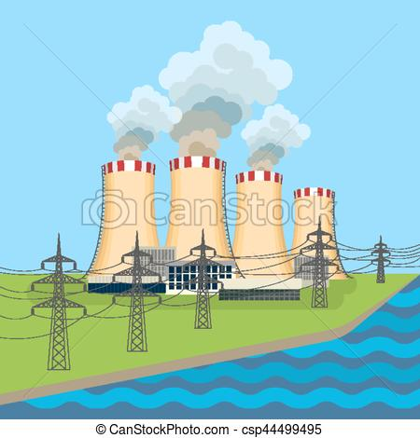 | - Power plant  Energy Transformation:

