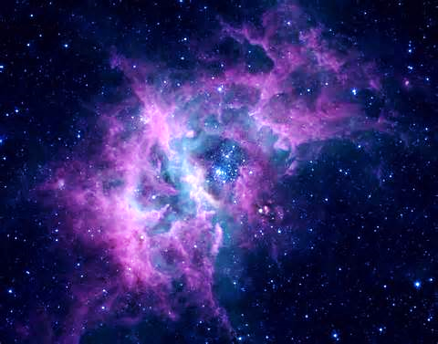  A | 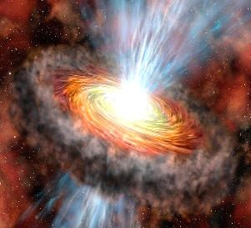  B | C | 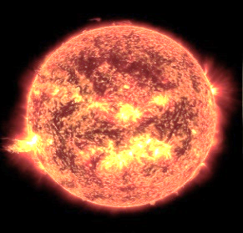  D
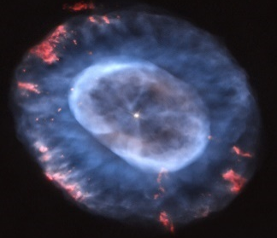  E | F | 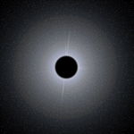  G | 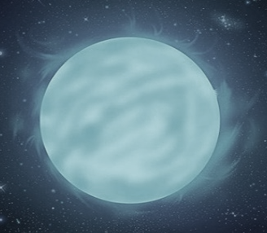  H
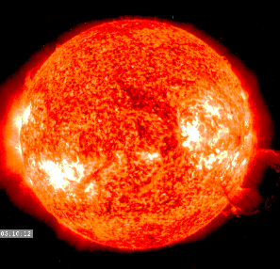  I | 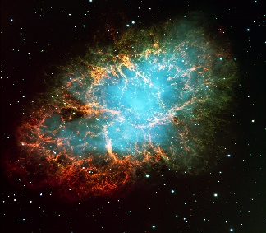  J | 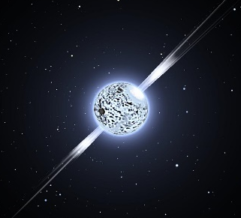  K | 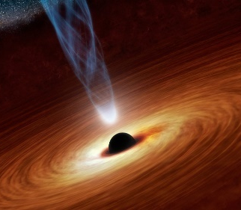  L

Stellar nebula  A cloud of dust and hydrogen gas that is compressed, due to gravity, to form a star. | Protostar  B  The early stage of a star where hydrogen gases and dust condenses and gets extremely hot due to friction of atoms. There is no nuclear fusion yet. | Main sequence  C  (regular star)  The young-adult stage of a star. Hydrogen burns for billions of years and becomes Helium through nuclear fusion. Our sun is in this stage. | Red Giant  At this stage, the star burns helium until it forms a carbon core and other heavier elements. This sun will grow 100 times bigger than its normal size giving a red glow color
Planetary Nebula  E  The weak gravity of the star allows all its gases to drift away into space, giving a nice and colorful scenery | White dwarf  F  The remains of a dying star after all the gases have drifted away. It will remain very hot and bright for millions of years until it cools down | Black dwarf  G  A dead star that is no longer hot nor bright. | Main sequence  H  (massive star)  Like our sun, this star burns Hydrogen for millions (not billions) of years with nuclear fusion, forming Helium at the core.
Red Super Giant  I  A growing star burning helium gas in its core until the fusion of heavier elements (like iron) occurs. | Super nova  J  The collapse of the core happens in less than a second creating a huge explosion that is brighter than the entire galaxy. | Neutron star  K  If the star survives the explosion, the core condenses into a tiny, and super heavy material used to make hammers for Thor | Black Hole  L  After the super nova explosion, the gravity of the collapsing core becomes so strong that not even light can escape from being suctioned
D
A

A cloud of dust and hydrogen gas that is compressed, due to gravity. This will form a new star. | The early stage of a star where hydrogen gases and dust condenses and gets extremely hot due to friction of atoms. There is no nuclear fusion yet. | During this stage, hydrogen burns for billions of years and becomes Helium through nuclear fusion. Our sun is at this stage. | This star doesn’t have hydrogen gas anymore. Now is burning helium until it forms a carbon core. The weak gravity allows the sun to grow up to 100 times its normal size. It has a red color as the core fuses into heavier elements
The gases of this star drift away since the weak gravity cannot keep them in place any more. They usually display a beautiful scene. At this stage, the star will begin to die. | The remains of a dying star after all the gases have drifted away. It will remain very hot and bright for millions of years until it cools down | A dead star that is no longer hot nor bright. | Hydrogen burns for millions (not billions) of years with nuclear fusion. Similar to our sun but a lot bigger and with more mass
A massive star burning helium gas in its core that keeps growing into an enormous and red glowing star. In its core, the fusion of heavier elements (up to iron) occurs. | In this stage, the collapse of the core happens in less than a second creating a huge explosion that is brighter than the entire galaxy. | A star with only 20 km. of diameter that survived the super nova explosion. The core condensed into a tiny, and super heavy material that not even the Hulk can pick up a hammer made of this material. | After the explosion of a super nova, the gravity of the collapsing core becomes so strong that not even light can escape from being suctioned
These are the oldest galaxies and contain very old stars. It has an egg oval shape. This galaxy has no gases nor dust and contains very bright stars. | This is a middle- aged galaxy that looks like a pinwheel or a disk, with a bulge in the center. | These types of galaxies have no shape nor symmetry. These are the youngest of all galaxies and contain a lot of hydrogen gas and dust. | Our galaxy is a spiral galaxy. What is the name of our galaxy?
Where is our sun located on the milky way galaxy? | What type of gases are formed during fusion in a main sequence star | This galaxy seems to have many rotating arms extending from the center. The arms contain a lot of gases and dust | Who is the best science teacher in the world?

