Earth Layers and Convection Currents Labels

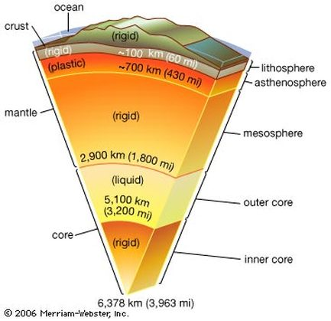

___________________

___________________

_________________

__________________

___________________

___________________

___________________

___________________

_____________________

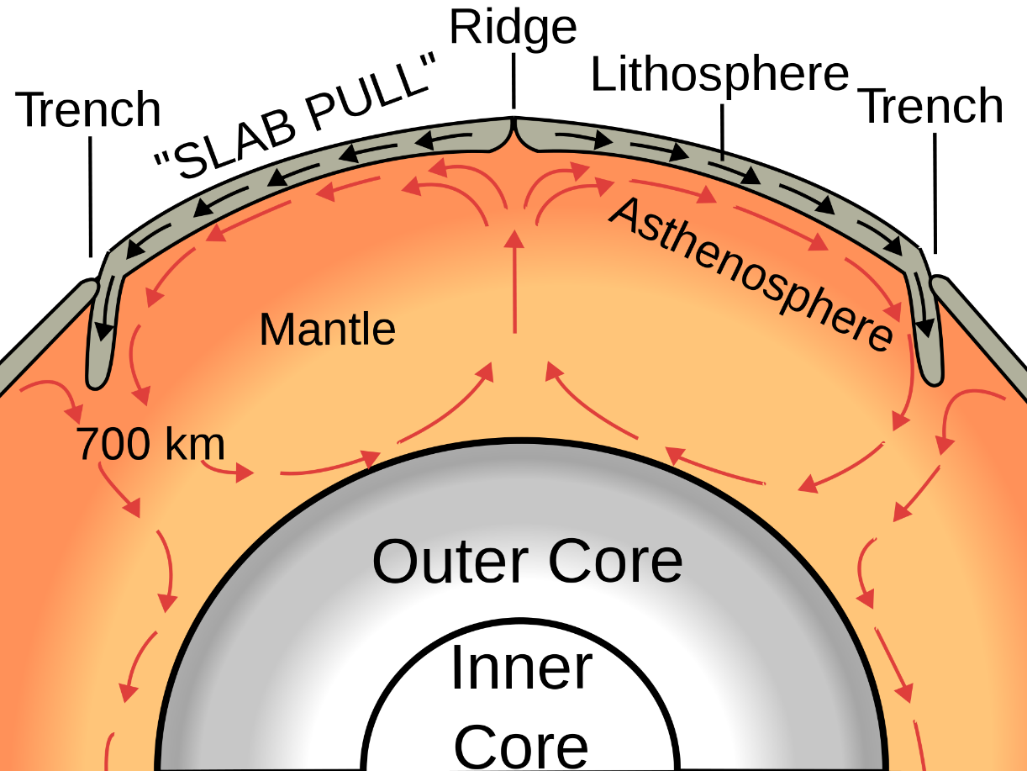

_____________________

______________________

___________________

___________________

**D**

**A**

___________________

**C**

___________________

**B**

______________________

_____________

_____________

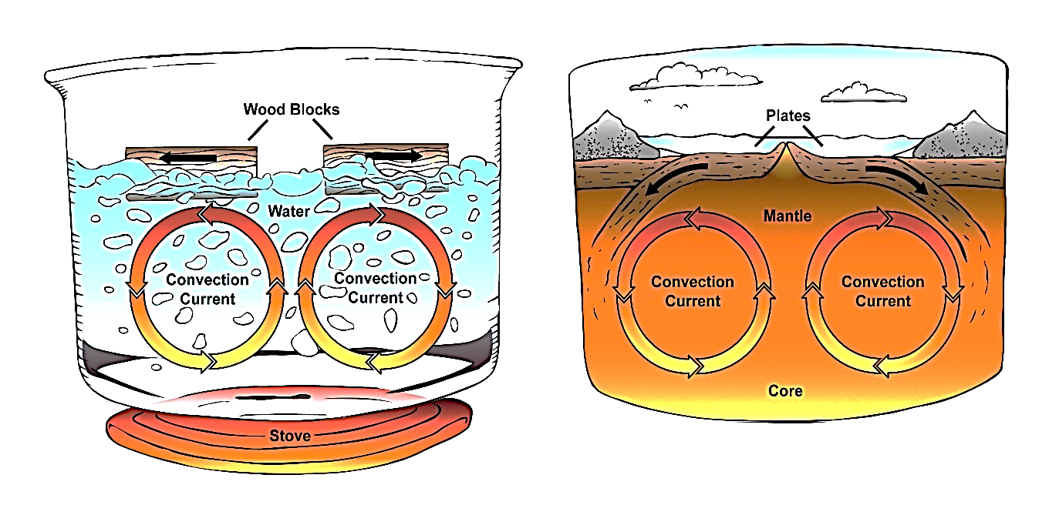

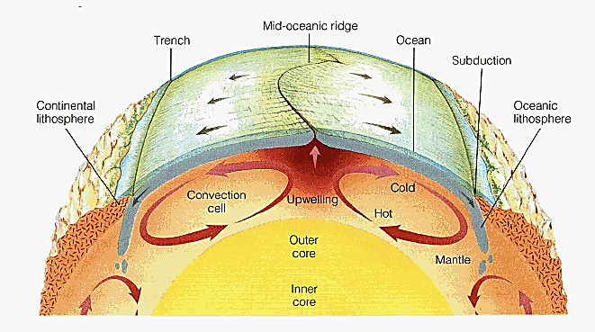

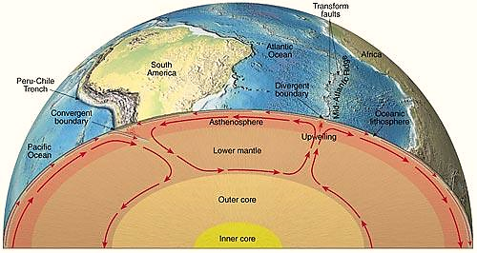

|  |  |
| --- | --- |
| http://higheredbcs.wiley.com/legacy/college/levin/0471697435/chap_tut/images/nw0137-nn.jpg | http://www.phschool.com/iText/sci_exp/ebook/products/0-13-181243-2/sx5006a3.gif |
| http://www.phschool.com/atschool/phsciexp/internet_activity/images/cfd-1014_midocean.jpg | http://volcanoes-in-aus.weebly.com/uploads/3/0/6/9/30691679/4410836_orig.png?1402734982 |

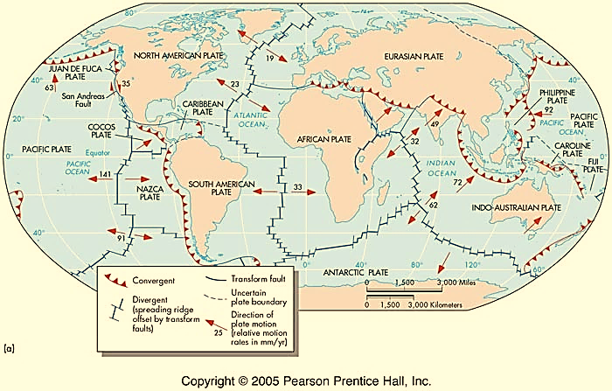

|  |  |
| --- | --- |
| http://higheredbcs.wiley.com/legacy/college/levin/0471697435/chap_tut/images/nw0137-nn.jpg | http://www.phschool.com/iText/sci_exp/ebook/products/0-13-181243-2/sx5006a3.gif |

