Name __________________________________________ Date _______________________ Period ________

Type of Galaxies Flip-book

Type of galaxy: _________________________

Description:

Age of galaxy:

Type of stars:

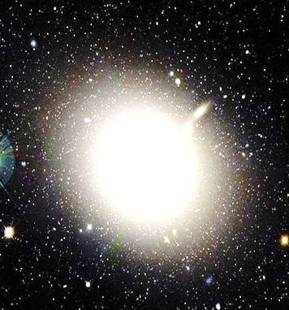 | Type of galaxy: _________________________  Description:  Age of Galaxy:  Type of stars:
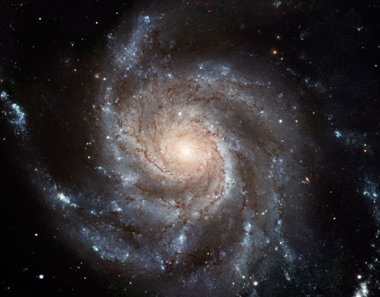 | Type of galaxy: _________________________  Description:  Age of Galaxy:  Type of stars:

Name ____________________________________ Date ____________________ Period _______
What type of galaxy is it?
